**I-STOCSY Users Guide**

Sands *et al.* Data-Driven Approach for Metabolite Relationship Recovery in Biological 1H NMR Data Sets Using Iterative Statistical Total Correlation Spectroscopy *Anal. Chem.* 2011, *83,* 2075-2082.

**MATLAB code required:**

ISTOCSY.m

ISTOCSY_Iplot.m

findPeaksKV.m (if peak picking required)

A detailed description of input (required and optional) and output arguments is provided in the ISTOCSY help:

>> help ISTOCSY

**Basic run:**

To run ISTOCSY with default settings:

>> out= ISTOCSY(X, ppm, driver);

This automatically generates the interactive plot of iterated STOCSY results, showing node-to-node associations alongside the corresponding spectral data. The output variable out is a structure containing all the running parameters, ISTOCSY node-to-node association information and the information required to generate the interactive plot.

In terms of the required input parameters X is the original spectral data, and ppm the corresponding ppm scale, driver is the ppm value of the peak from which to drive the initial STOCSY from.

For example:

>> out = ISTOCSY(X, ppm, 3.713);

**Additional input arguments:**

To run ISTOCSY with some user specified settings:

>> out= ISTOCSY(X, ppm, driver, in);

The final input argument ‘in’ is a structure with fields (and default settings) as described below.

**in.peakInds** = peak picked indices, if not included this will be generated using code written by Kirill Veselkov, which generates list of peak apex indices through detection at zero crossings of a smoothed spectral derivative calculated using a Savitzky-Golay third order polynomial filter of the mean spectrum.

**in.ISTOCSY_cutoff** = correlation threshold above which peaks-to-peak associations are saved and presented (default = 0.8).

**in.struct_cutoff** = correlation threshold for partitioning detected peak indices into putative structural sets (default = 0.95).

**in.Nrounds** = maximum number of ISTOCSY rounds to be run (default = 10). Although it should be noted that even if this number has not been exceeded, as soon as no new peaks are detected ISTOCSY will be terminated.

**in.name** = name by which to save the output and resultant interactive plot (default = date).

**in.corrColScale** = colour scale by which to colour the peaks in the ISTOCSY plot, peaks are coloured by strength of correlation. 'full' colours on scale from -1 to 1, 'min2max' colours on scale from min to max correlation (default = 'full').

**Output:**

Alongside the ‘out’ variable (which details all of the user specified and default parameters, and other variables generated in the ISTOCSY procedure), running ISTOCSY generates two plots.

The first plot (name_ISTOCSY_pickedPeaks.fig) shows all of the peaks included in the picked peak list. If any peaks of interest are not included, you can add these to the in.peakInds and in.allPeaks variables before re-running ISTOCSY.

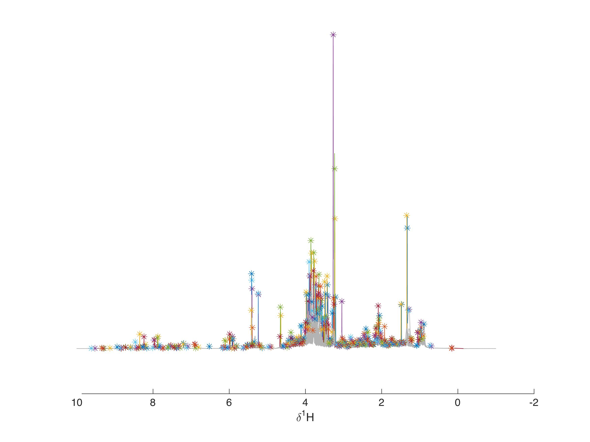

The second (and main) plot (name_ISTOCSY_plot.fig) is an interactive plot of the results of ISTOCSY. The top panel (running from left to right) shows the node-to-node connectivity, where each node represents a cluster of structurally related peaks, and the initial driver is the node on the far left. The black node is the peak from which we are looking at connections to, and will initially be that of the driver peak. The bottom panel highlights the corresponding spectral data. Here, the stars underneath the spectrum show which peaks are contained in each node (the colours correspond to those in the top panel), and the colour of the peak itself shows the strength of the correlation of those peaks to the driver (colour scale on right).

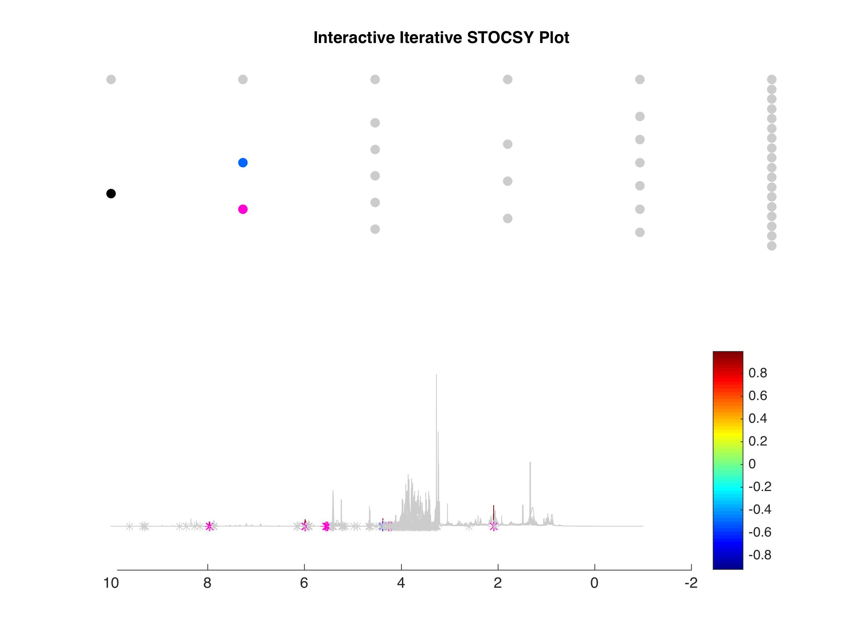

This plot is fully interactive, you can use the cursor to select either a node in the top plot, or a peak (by clicking on the star below the peak) in the bottom plot. This will change that node/star to black, and show all the correlations to other nodes/peaks (above your ISTOCSY threshold). You can also use the zoom tool to zoom in on the spectral data. If you cannot get the interactivity to work, please check you have no figure tools selected (for example, the arrow), as then it will not work! You can deselect any tool by clicking on it with your cursor.

**Any queries?**

caroline.sands01@imperial.ac.uk